Direct Deposit Instruction
- Go to UAOnline at https://uaonline.alaska.edu
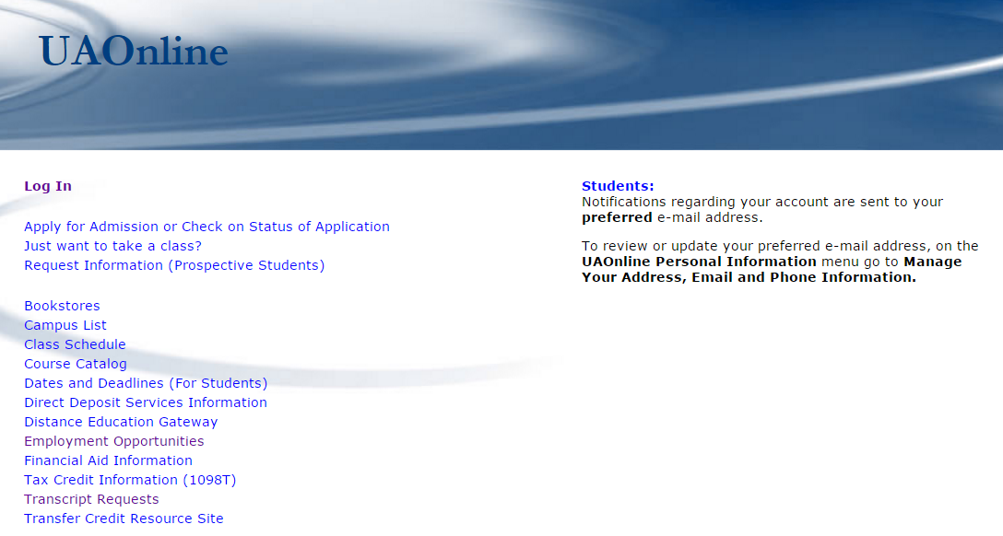

- From your welcome screen, click on the first tab Student Services and Account Information.

- Select Direct Deposit Services option under Student Services & Account Information tab.
- Choose First time setup of direct deposit on Direct Deposit Services Page.
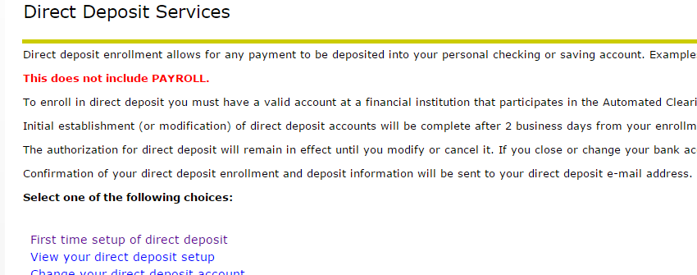

- Enter bank account number, routing number and your email address. Verify your information and submit.
